Size

Definition
# Source: AI Source: Provided by: [Data Path: Persons Table -> ID Column: 1, Name_En Column: Motasem Essam] -> From: [ChatGPT] on [7/20/2026]
Size is a quantitative or comparative property that describes how large or small an object, shape, region, or geometric figure is.
In geometry, size is commonly determined using measurable quantities such as:
- Length
- Width
- Height
- Radius
- Diameter
- Perimeter
- Area
- Surface area
- Volume
The appropriate measure depends on the type and dimension of the object.

Fundamental Concept
# Source: AI Source: Provided by: [Data Path: Persons Table -> ID Column: 1, Name_En Column: Motasem Essam] -> From: [ChatGPT] on [7/20/2026]
Size answers the question:
How large is something?
For example:
- A line segment has a length.
- A circle has a radius, diameter, and circumference.
- A 2D region has an area.
- A 3D solid has a volume.
Thus, size is not necessarily represented by one universal formula.

Basic Structure
# Source: AI Source: Provided by: [Data Path: Persons Table -> ID Column: 1, Name_En Column: Motasem Essam] -> From: [ChatGPT] on [7/20/2026]
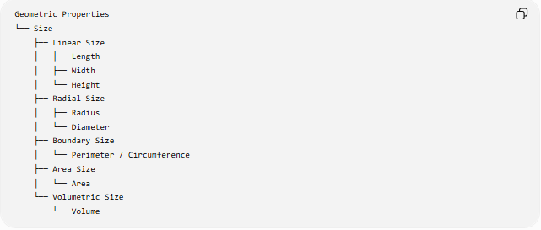
Geometric Properties
└── Size
├── Linear Size
│ ├── Length
│ ├── Width
│ └── Height
├── Radial Size
│ ├── Radius
│ └── Diameter
├── Boundary Size
│ └── Perimeter / Circumference
├── Area Size
│ └── Area
└── Volumetric Size
└── Volume

Types of Size

1. Linear Size
# Source: AI Source: Provided by: [Data Path: Persons Table -> ID Column: 1, Name_En Column: Motasem Essam] -> From: [ChatGPT] on [7/20/2026]
Measures a distance in one dimension.
Examples:
$$\boxed{L=10\text{ cm}}$$
A rectangle may have:
$$\text{Length}=8\text{ cm} \\ \text{Width}=5\text{ cm}$$

2. Radial Size
# Source: AI Source: Provided by: [Data Path: Persons Table -> ID Column: 1, Name_En Column: Motasem Essam] -> From: [ChatGPT] on [7/20/2026]
Used particularly for circular shapes.
For a circle:
$$\boxed{d=2r}$$
where:
- $r$= radius
- $d$= diameter
A larger radius means a larger circle.

3. Perimeter or Circumference
# Source: AI Source: Provided by: [Data Path: Persons Table -> ID Column: 1, Name_En Column: Motasem Essam] -> From: [ChatGPT] on [7/20/2026]
Measures the total length around a 2D shape.
For a rectangle:
$$\boxed{P=2\left(l+w\right)}$$
For a circle:
$$\boxed{C=2πr}$$

4. Area
# Source: AI Source: Provided by: [Data Path: Persons Table -> ID Column: 1, Name_En Column: Motasem Essam] -> From: [ChatGPT] on [7/20/2026]
Measures the amount of 2D space occupied by a region.
For a rectangle:
$$\boxed{A=lw}$$
For a circle:
$$\boxed{A=πr^{2}}$$
Area uses square units:
$${\text{cm}}^{2}, {\text{m}}^{2}, {\text{km}}^{2}$$

5. Volume
# Source: AI Source: Provided by: [Data Path: Persons Table -> ID Column: 1, Name_En Column: Motasem Essam] -> From: [ChatGPT] on [7/20/2026]
Measures the amount of 3D space occupied by a solid.
For a rectangular prism:
$$\boxed{V=lwh}$$
For a sphere:
$$\boxed{V=\frac{4}{3}πr^{3}}$$
Volume uses cubic units:
$${\text{cm}}^{3}, {\text{m}}^{3}$$

Size vs Shape
# Source: AI Source: Provided by: [Data Path: Persons Table -> ID Column: 1, Name_En Column: Motasem Essam] -> From: [ChatGPT] on [7/20/2026]
Size and shape describe different properties.
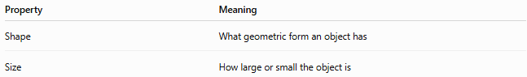
Property | Meaning
Shape | What geometric form an object has
Size | How large or small the object is
For example, two circles can have the same shape but different sizes:
$$r_{1}=2 \\ r_{2}=5$$
Both are circles, but the second is larger.

Scaling and Size
# Source: AI Source: Provided by: [Data Path: Persons Table -> ID Column: 1, Name_En Column: Motasem Essam] -> From: [ChatGPT] on [7/20/2026]
A shape can be enlarged or reduced by a scale factor $k$.
If every linear dimension is multiplied by $k$:
$$\boxed{L^{'}=kL}$$
For a 2D shape:
$$\boxed{A^{'}=k^{2}A}$$
For a 3D object:
$$\boxed{V^{'}=k^{3}V}$$
Therefore:
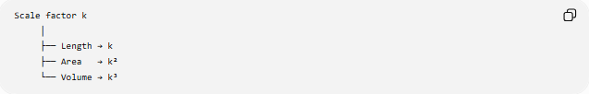
Scale factor k
│
├── Length → k
├── Area → k²
└── Volume → k³
Example
If a shape is enlarged by:
$$k=2$$
then:
- Lengths become $2$times larger.
- Areas become $4$times larger.
- Volumes become $8$times larger.

Comparison of Size Measures
# Source: AI Source: Provided by: [Data Path: Persons Table -> ID Column: 1, Name_En Column: Motasem Essam] -> From: [ChatGPT] on [7/20/2026]
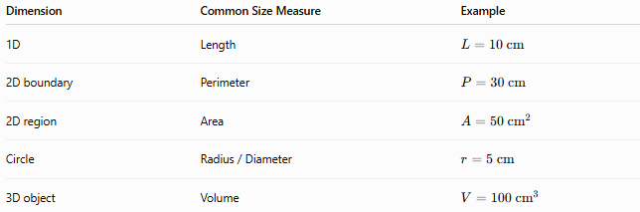
Dimension | Common Size Measure | Example
1D | Length | $$L=10\text{ cm}$$
2D boundary | Perimeter | $$P=30\text{ cm}$$
2D region | Area | $$A=50{\text{ cm}}^{2}$$
Circle | Radius / Diameter | $$r=5\text{ cm}$$
3D object | Volume | $$V=100{\text{ cm}}^{3}$$

Classification
# Source: AI Source: Provided by: [Data Path: Persons Table -> ID Column: 1, Name_En Column: Motasem Essam] -> From: [ChatGPT] on [7/20/2026]
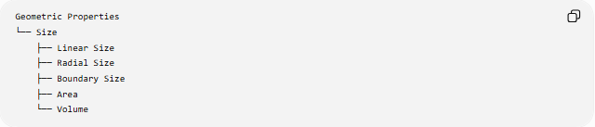
Geometric Properties
└── Size
├── Linear Size
├── Radial Size
├── Boundary Size
├── Area
└── Volume

Key Points
# Source: AI Source: Provided by: [Data Path: Persons Table -> ID Column: 1, Name_En Column: Motasem Essam] -> From: [ChatGPT] on [7/20/2026]
- Size describes how large or small a geometric object or region is.
- It can be measured in different ways depending on the object.
- Length measures one-dimensional extent.
- Area measures two-dimensional extent.
- Volume measures three-dimensional extent.
- Radius and diameter are important size measures for circles.
- Perimeter and circumference measure boundary length.
- Scaling changes size while potentially preserving shape.
- Under scale factor $k$:
$$L→kL, A→k^{2}A, V→k^{3}V$$

Conclusion
# Source: AI Source: Provided by: [Data Path: Persons Table -> ID Column: 1, Name_En Column: Motasem Essam] -> From: [ChatGPT] on [7/20/2026]
Size is a geometric property describing the magnitude or extent of an object or shape. It can be expressed through length, radius, diameter, perimeter, area, or volume, depending on the geometric dimension and structure. Shape describes what something is, while size describes how large or small it is.

